**Experiment 5**

**Draw the activity diagram for the specified Case Study.**

An activity diagram for a blood donation project provides a visual representation of the flow of activities involved in the process of blood donation. Here's a short note explaining the key components and features:

1. **Start and End Nodes:** The diagram begins with a start node indicating the initiation of the blood donation process and ends with an end node indicating the completion of the process.
2. **Activities:** The main activities involved in the blood donation process are depicted as nodes in the diagram. These activities include:

* Registration: Donors provide necessary personal and health information.
* Health Screening: Donors undergo medical checks to ensure they meet eligibility criteria for blood donation.
* Donation: The actual process of donating blood.
* Post-Donation Refreshment: Donors receive refreshments and rest after donation.
* Data Recording: Information about the donation is recorded for future reference.

1. **Decisions/Conditions:** Decision points or conditions may be depicted using diamond-shaped nodes. For example:

* **Eligibility Check:** Whether the donor meets the criteria for blood donation.
* **Health Assessment:** Determining if the donor is fit for donation based on medical tests.

1. **Arrows/Transitions:** Arrows indicate the flow of control or transition between activities. They show the sequence in which activities are performed.
2. **Parallel Activities:** Parallel lines indicate activities that can occur simultaneously. For instance, while some donors are undergoing health screening, others may be registering or donating blood.
3. **Loops/Iterations:** Some activities may involve iterative processes, such as repeated attempts to collect blood if the initial attempt fails.
4. **Exception Handling:** Exceptional cases, such as donors being ineligible for donation or experiencing complications during or after donation, can be represented with alternative pathways in the diagram.
5. **Feedback/Communication:** Communication channels between stakeholders, such as donors, medical staff, and administrative personnel, can be depicted to show information exchange throughout the process.

In summary, an activity diagram for a blood donation project offers a comprehensive visualization of the steps involved in the donation process, helping to identify potential bottlenecks, streamline workflows, and ensure a smooth and efficient operation of the blood donation program.

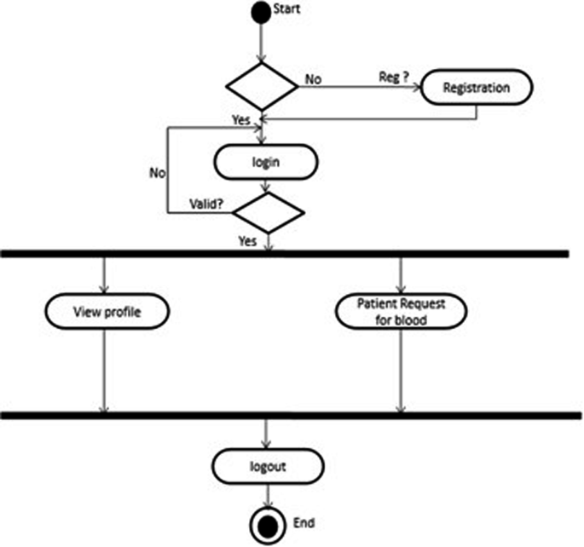

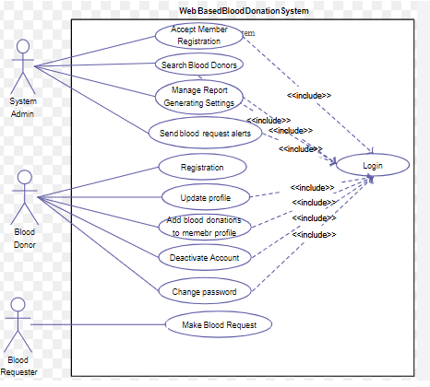

Fig. Activity Diagram